**IBM ASSIGNMENT-1**

**THE CASE OF 50 STARTUPS**

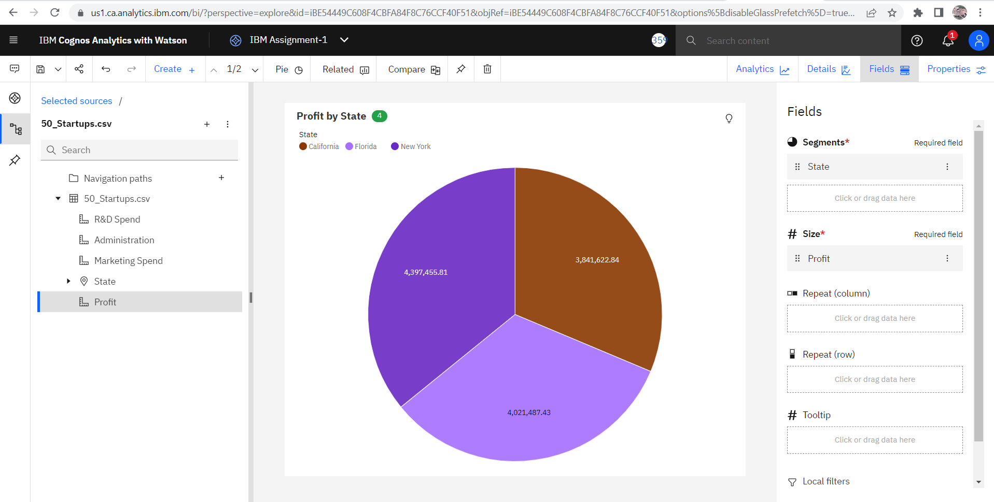

The above pie chart shows that profits of all the startups in all states are nearly equal and vary with the slightest difference. But, New York has the highest profit.

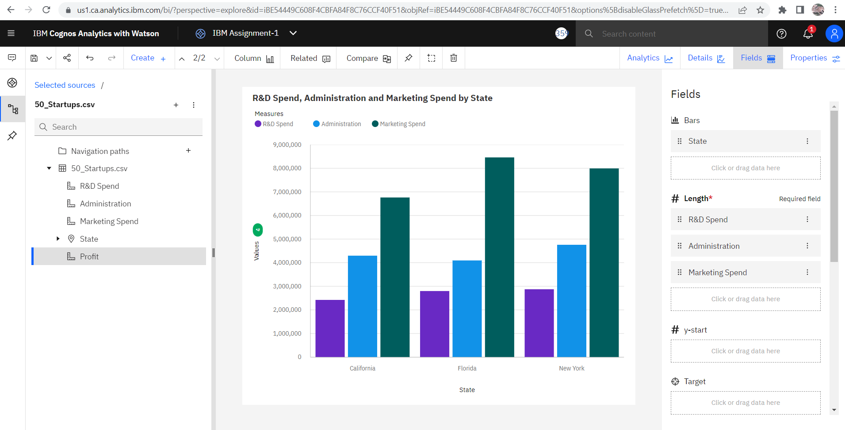

In the above column, the state where they provide maximum amount for R&D spend manages to produce the profit. Even there exists only a **slightest change in R&D spend but that has resulted to the slightest change in the profit**. And thereby the order of profit goes like New York followed by Florida and then California. And it is the same order in terms of R&D spend also.

Aggregate can be changed with the help of the drop-down :



If we change the aggregate in the properties to Average to all that is in R&D spend, Administration, Marketing Spend which was total before, we find that Florida tops in all that is in R&D spend, Administration, Marketing Spend.

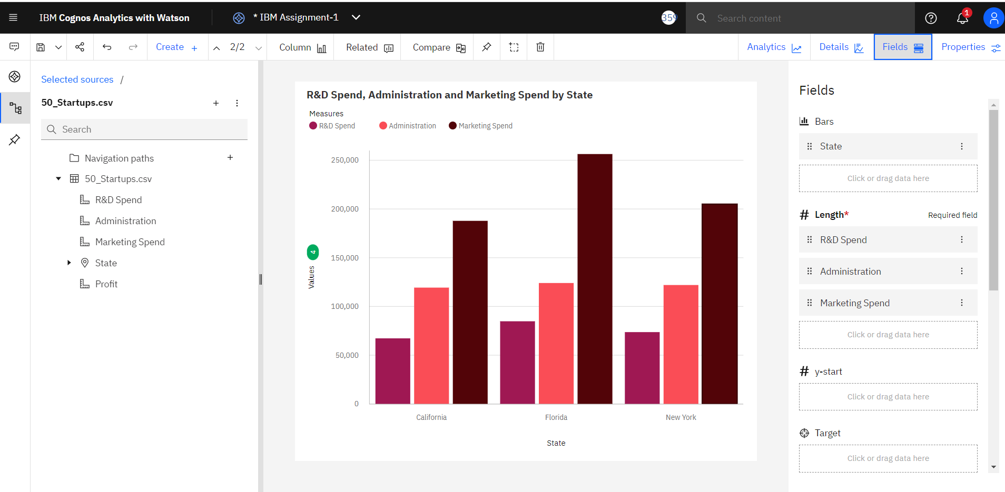 And we change the aggregate in the properties to Maximum to all that is in R&D spend, Administration, Marketing Spend we find that New York is Maximum in Marketing Spend and R&D spend.

 And we change the aggregate in the properties to Minimum to all that is in R&D spend, Administration, Marketing Spend we find that Florida is maximum in terms of minimum in all that is in R&D spend, Administration, Marketing Spend.



So, hence I conclude that if **R&D spend is directly proportional to the profit** by the startups in the state. So, concentrating in R&D spend is important.

**Assignment-1 Link :** <https://us1.ca.analytics.ibm.com/bi/?perspective=explore&pathRef=.my_folders%2FIBM%2BAssignment%2FIBM%2BAssignment-1&subView=model000001834fd6104c_00000004>